Dual-Band 600Mbps AC Wireless USB Adapter
Including HIGH GAIN antenna
2.4Ghz and 5Ghz for congestion free WiFi

WL-700AN-AC-S

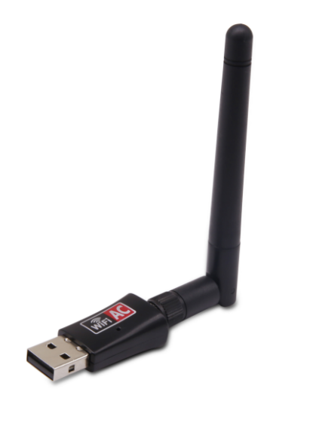

Description
The new, nano-sized WL-700AN-AC is a high-performance, dual-band WiFi USB adapter for both WindowsTM and MacTM OS X that offers congestion-free, high-speed WiFi capabilities for the next generation applications including HD movie streaming, online gaming and more.
Offering a combined WiFi speed of up to 600Mbps, via automatically connecting to your broadband router or access point at either 2.4Ghz or 5Ghz. The latest 5Ghz band makes use of less WiFi congestion than regular WiFi clients, even in a busy office environment.

Features
- Dual-band 802.11AC WiFi connectivity
- 2.4Ghz and 5.0Ghz congestion free WiFi
- Up to 600Mbps WiFi communications
- Enhanced WiFi Encryption to keep signals safe
- Ideal for current, future and existing WiFi Routers etc
- Plug n' Play for WindowsTM, MacTM OS X and LinuxTM

Specifications
- Standards:IEEE802.11ac/a/b/g/n
- Interface Type:USB 2.0/1.1
- Transmission Rate:600Mbps(5G:433M/2.4G:150M)
- Frequency Range :2.4G:2415MHz-2483MHz 5g:5150MHz-5825MHz
- Modulation:802.11ac: MU-MIMO 802.11a: 5G OFDM 802,11n: MIMO-OFDM/CCK/DSSS 802.11g: CCK/DSSS/OFDM 802.11b: CCK/DSSS
- RF Power:2.4G: 16DBm(MAX EIRP) 5G: 13DBm(MAX EIRP)
- 2DBI
- Data Security:Antenna Gain:WEP/WPA/WPA2/WAPI/WPS
- LED Light:Status
- Operating Temperature: 0oC-40oC
- Operating Humidity: 10%-85% RH non-condensing
- Storage Temperature: 20C-60C
- Storage Humidity: 5%-90% RH non-condensing
- Supported OS:Windows XP/7/8/10/MAC OSX/Linux

